# ACTIVITY 03

## Question 1:

**READ FROM TWO FLAT FILES AND ONE TABLE FROM ANY SQL DATABASE**

# STEPS FOR ACTIVITY 3 QUESTION 1

1. OPEN MYSQL AND CREATE DATABASE AND TABLES ALSO INSERT SOME DATA IN IT.
2. NOW CREATE 2 FLAT FILES AS WE DONE IN ACTIVITY 2 OR USE THE SAME FILES.
3. OPEN SSMS AND CREATE DATABASE AND TABLES.
4. OPEN VISUAL STUDIO AND CREATE DATA FLOW AND CONNECTIONS FOR YOUR DATA.

### STEP 1

create database DWass2;

use DWass2;

create table Customer(

id int,

Firstname varchar(50),

Lastname varchar(50),

Address varchar(50),

Phone_Number varchar(11)

);

-- truncate table customer;

insert into customer(id,Firstname,Lastname,Address,Phone_Number) values(300,'Omer','Siddiqui','Bahadurabad','03052295554');

insert into customer(id,Firstname,Lastname,Address,Phone_Number) values(301,'Ahsan','Amir','Gulshan','03052456443');

insert into customer(id,Firstname,Lastname,Address,Phone_Number) values(302,'Faaiz','Faroqi','PIB','03003982773');

insert into customer(id,Firstname,Lastname,Address,Phone_Number) values(303,'Farooq','Ahmed','Golimar','03876354323');

insert into customer(id,Firstname,Lastname,Address,Phone_Number) values(304,'Naseeb','Ullah','Malir','03627283742');

insert into customer(id,Firstname,Lastname,Address,Phone_Number) values(305,'Muavia','Khan','Maymar','033926473629');

insert into customer(id,Firstname,Lastname,Address,Phone_Number) values(306,'Maaz','Qalandar','Johar','03256373849');

insert into customer(id,Firstname,Lastname,Address,Phone_Number) values(307,'Saim','Mehmood','Cantt','03006473838');

select * from customer;

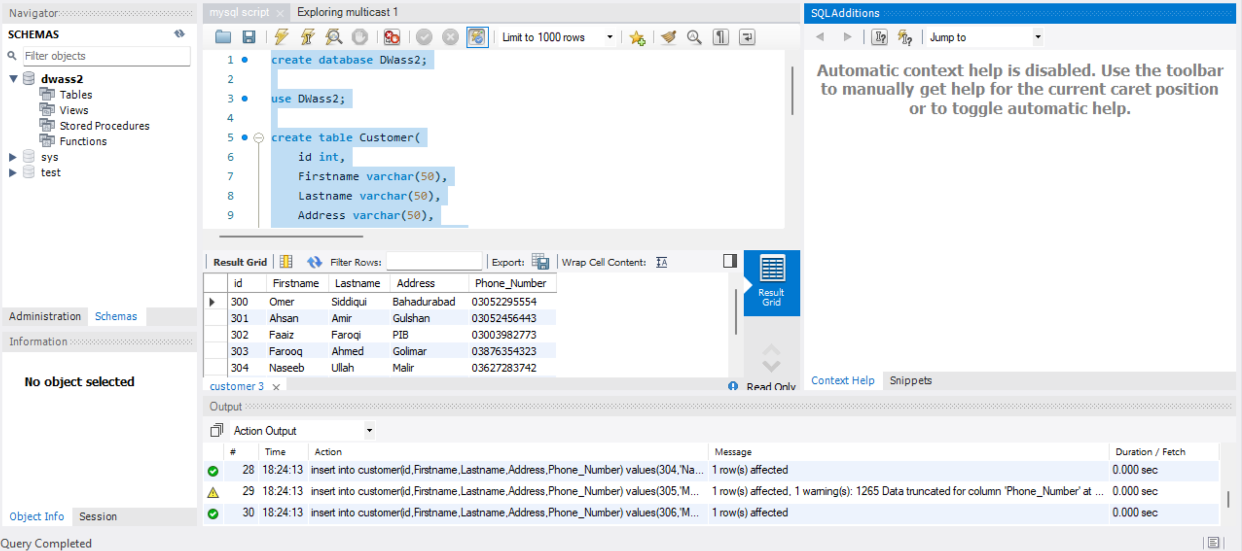

### STEP 2

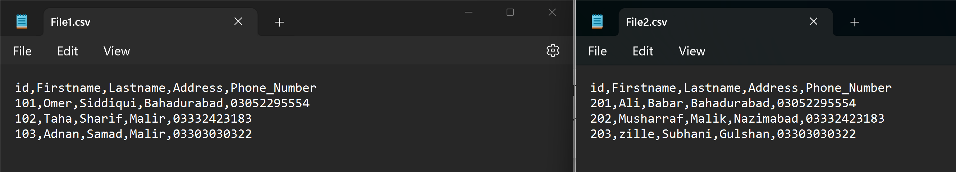

### STEP 3

--create database [DWH assignment];

use [DWH assignment ];

create table dbo.Customers(

id int,

Firstname varchar(50),

Lastname varchar(50),

Address varchar(50),

Phone_Number varchar(11)

);

select * from dbo.Customers;

-- truncate table dbo.Customers;

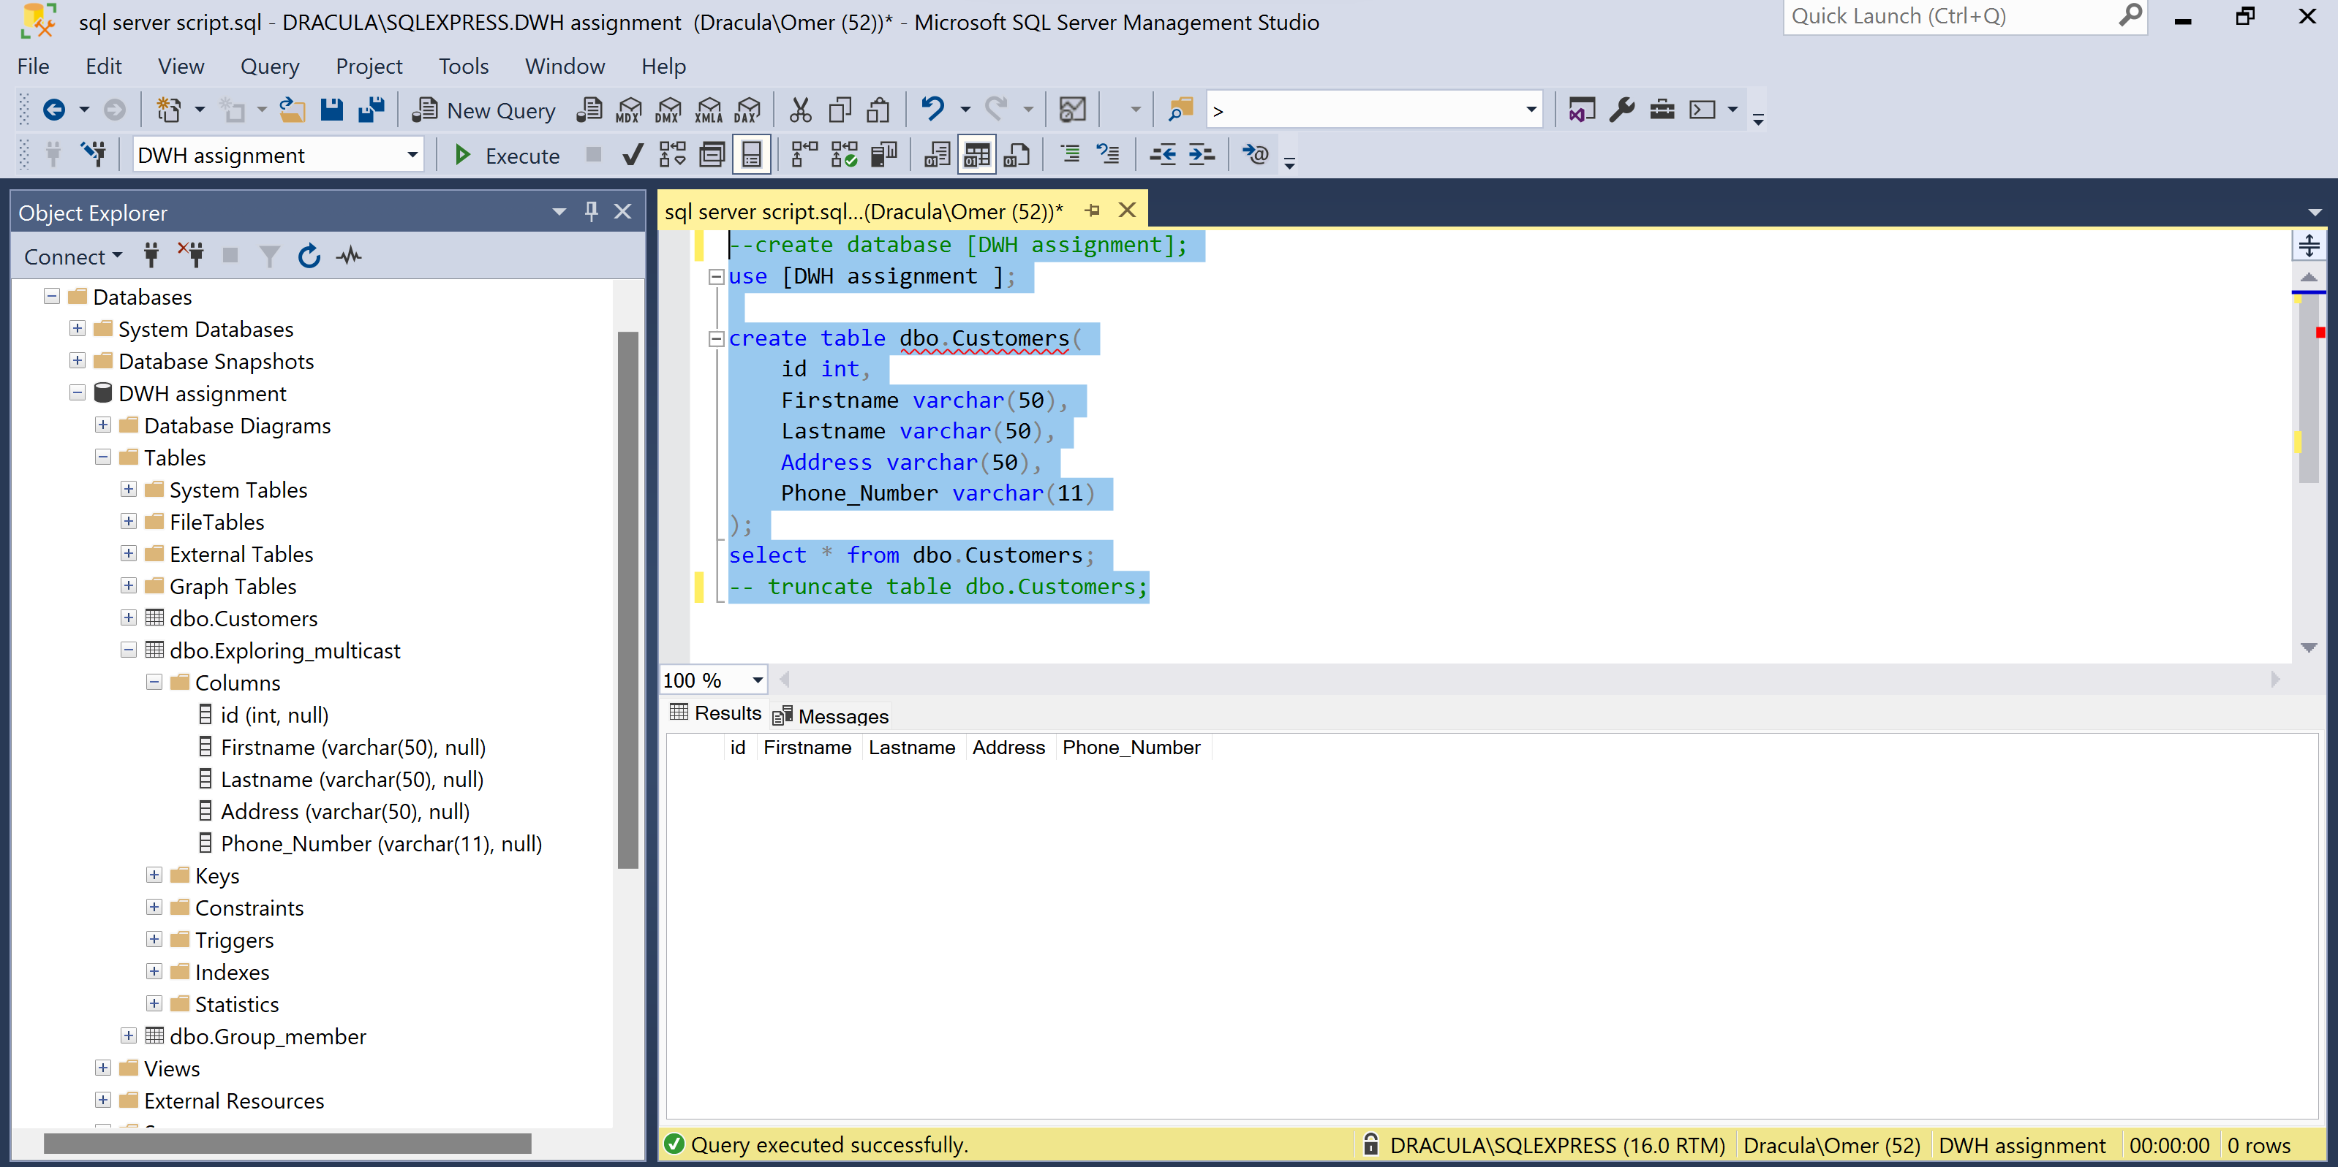

### STEP 4

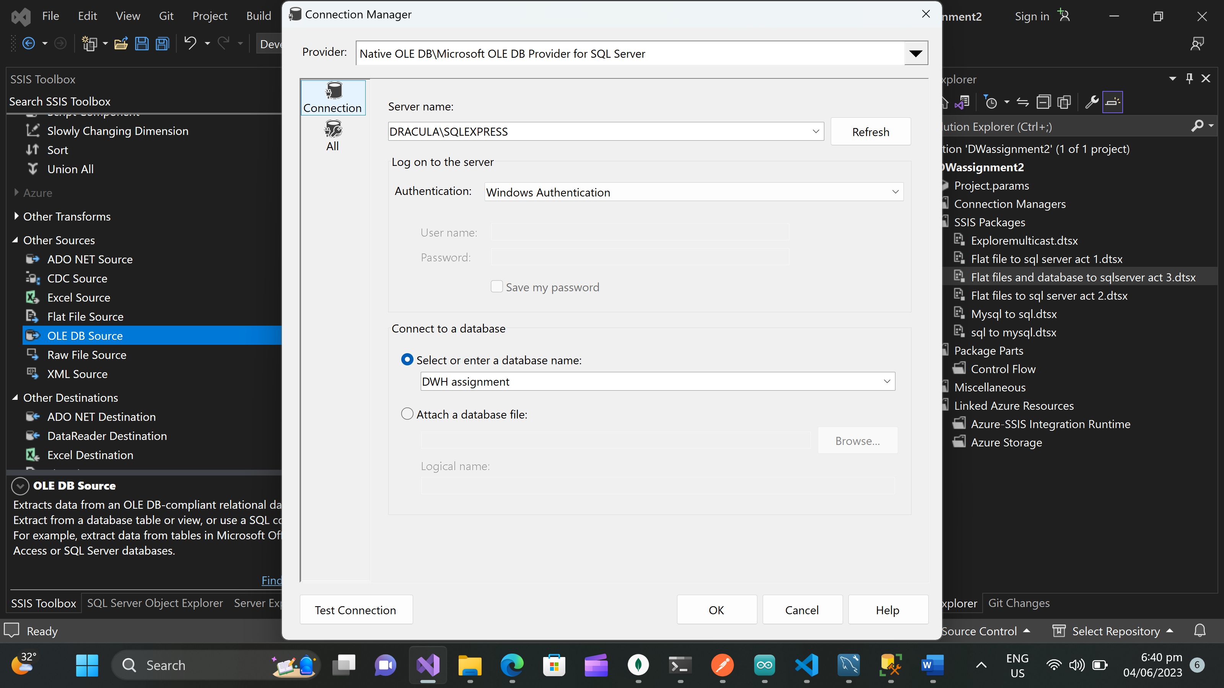 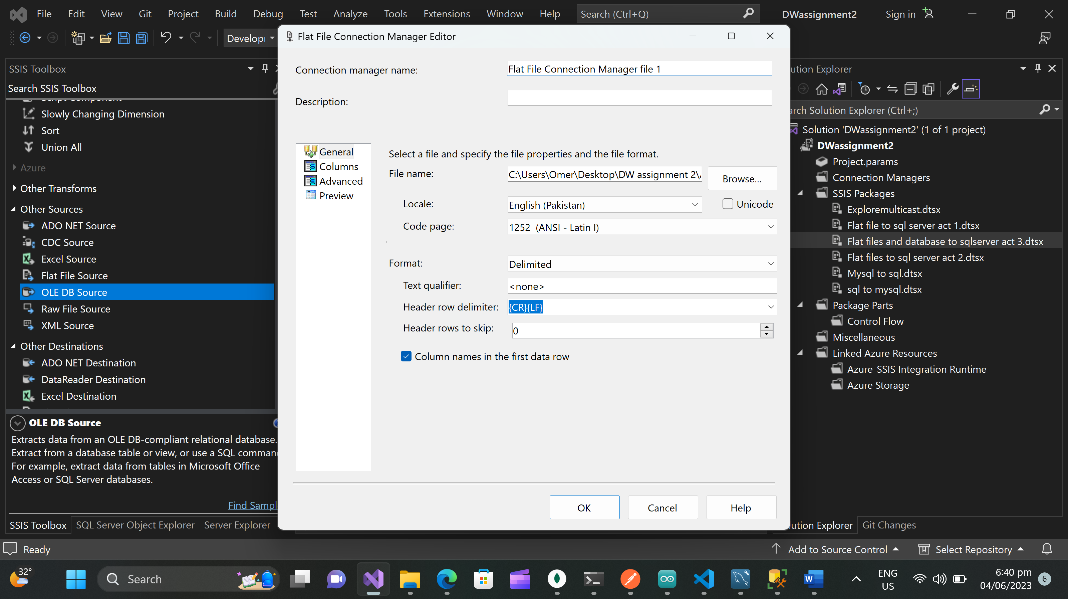 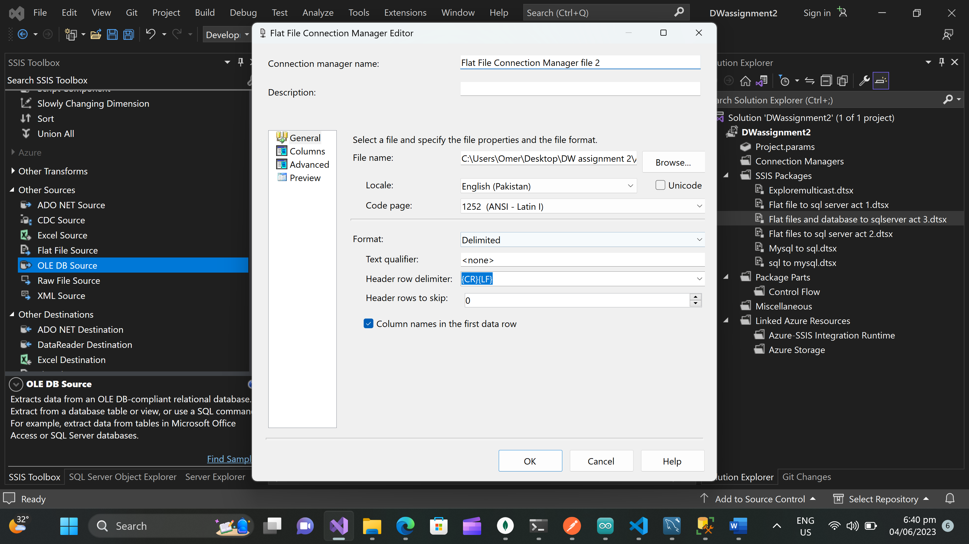 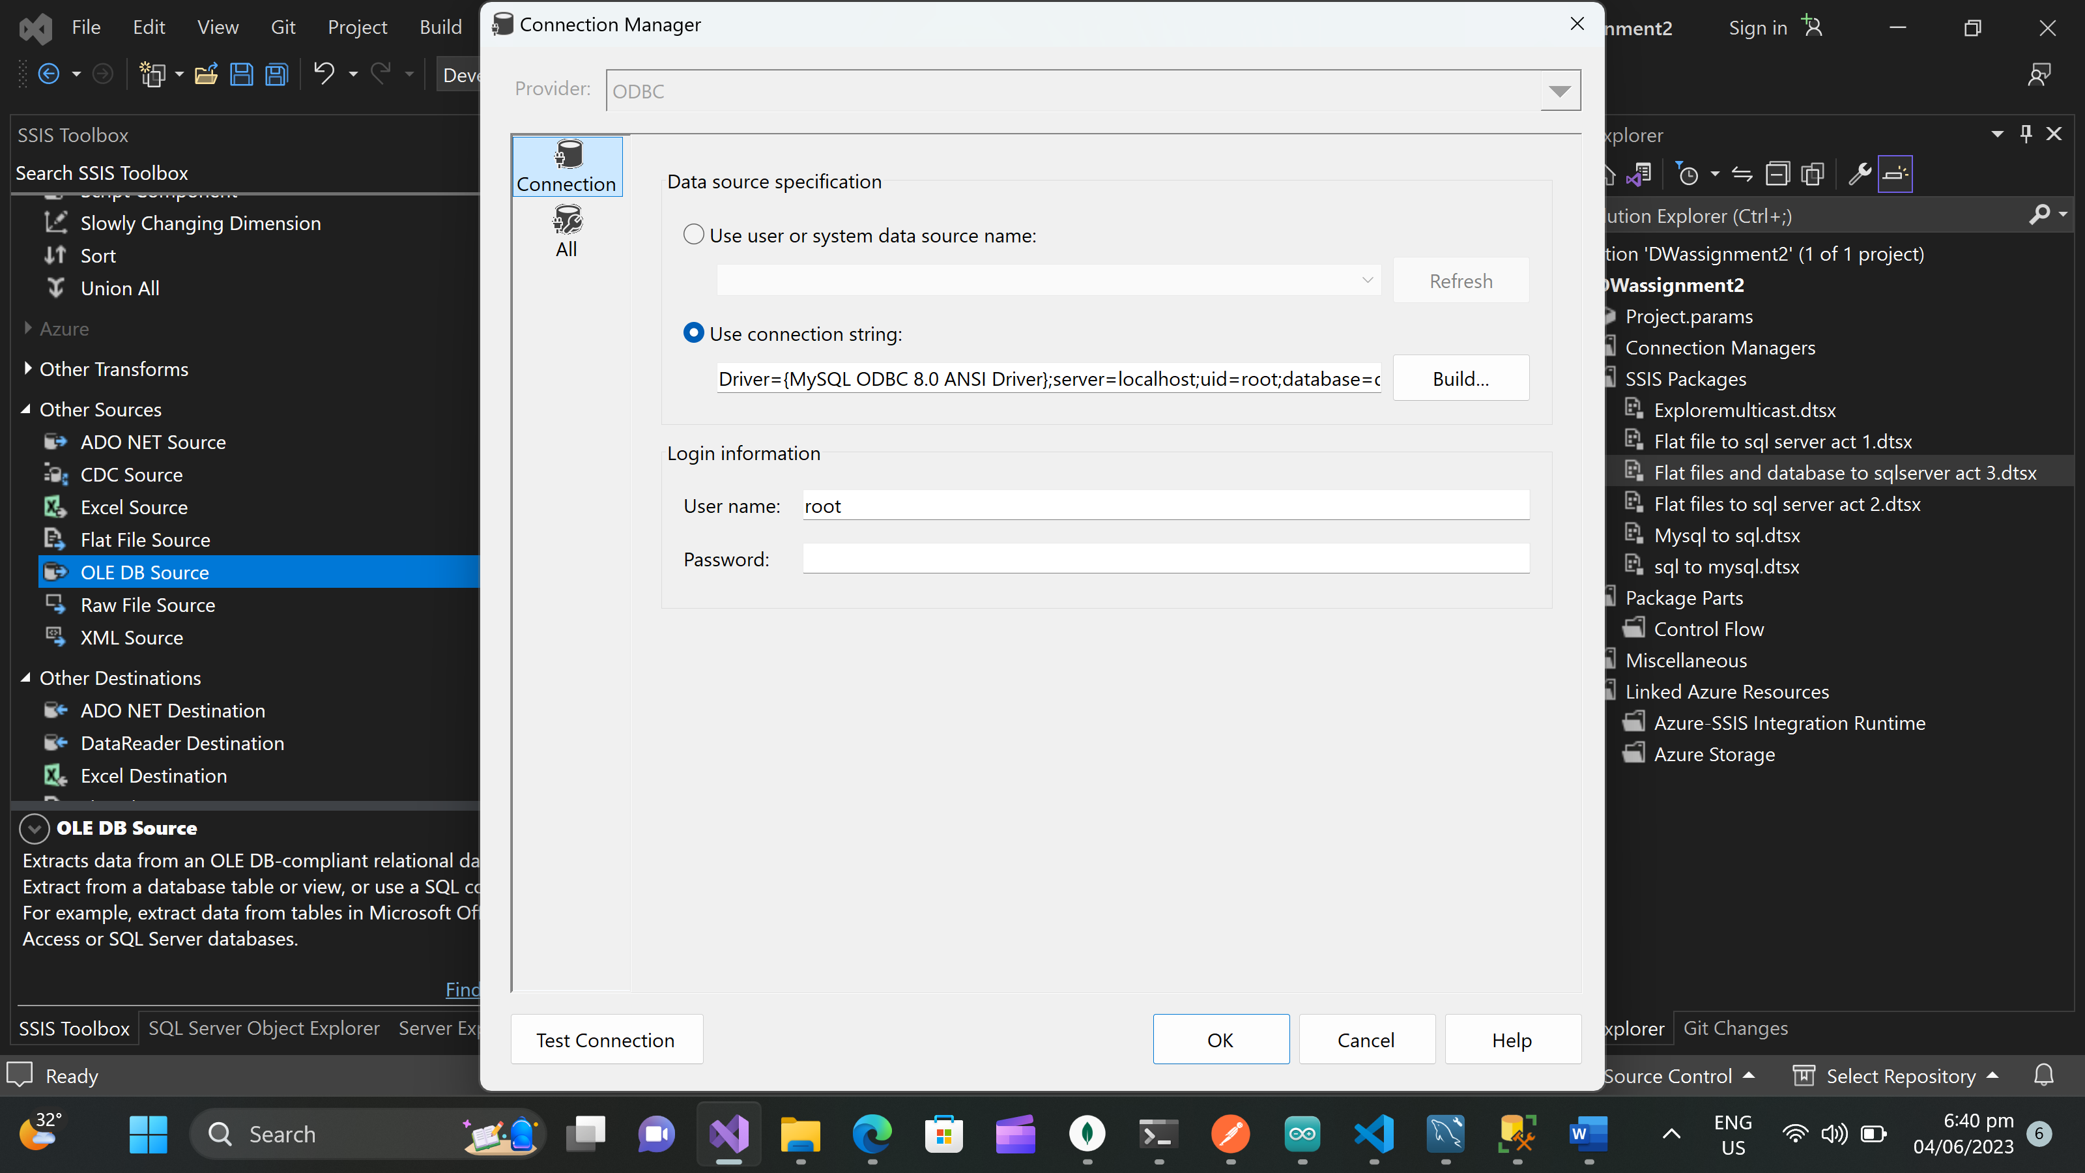 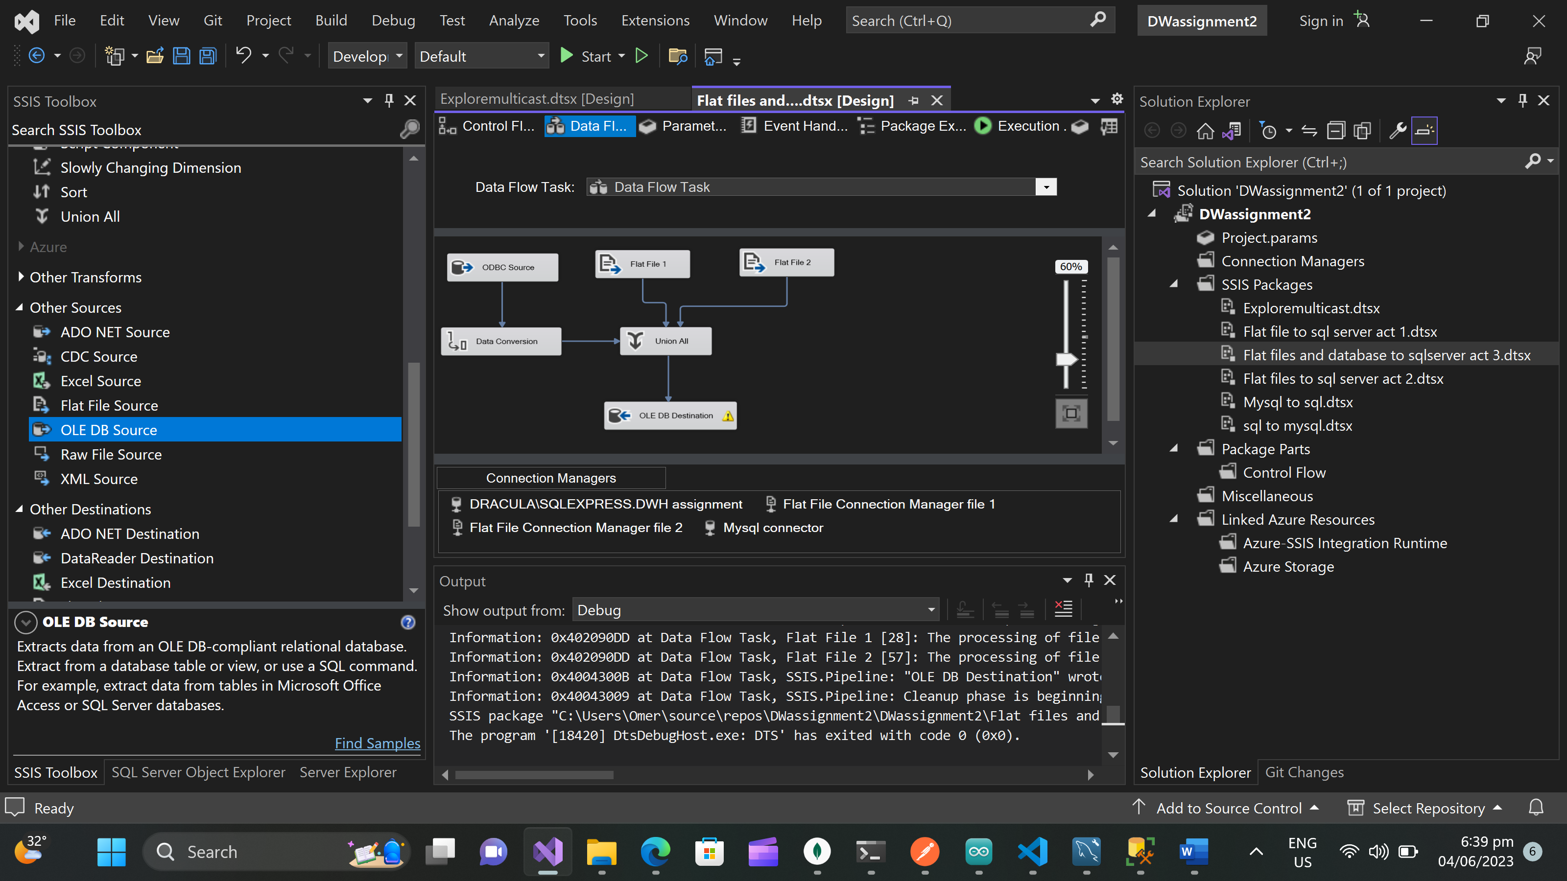

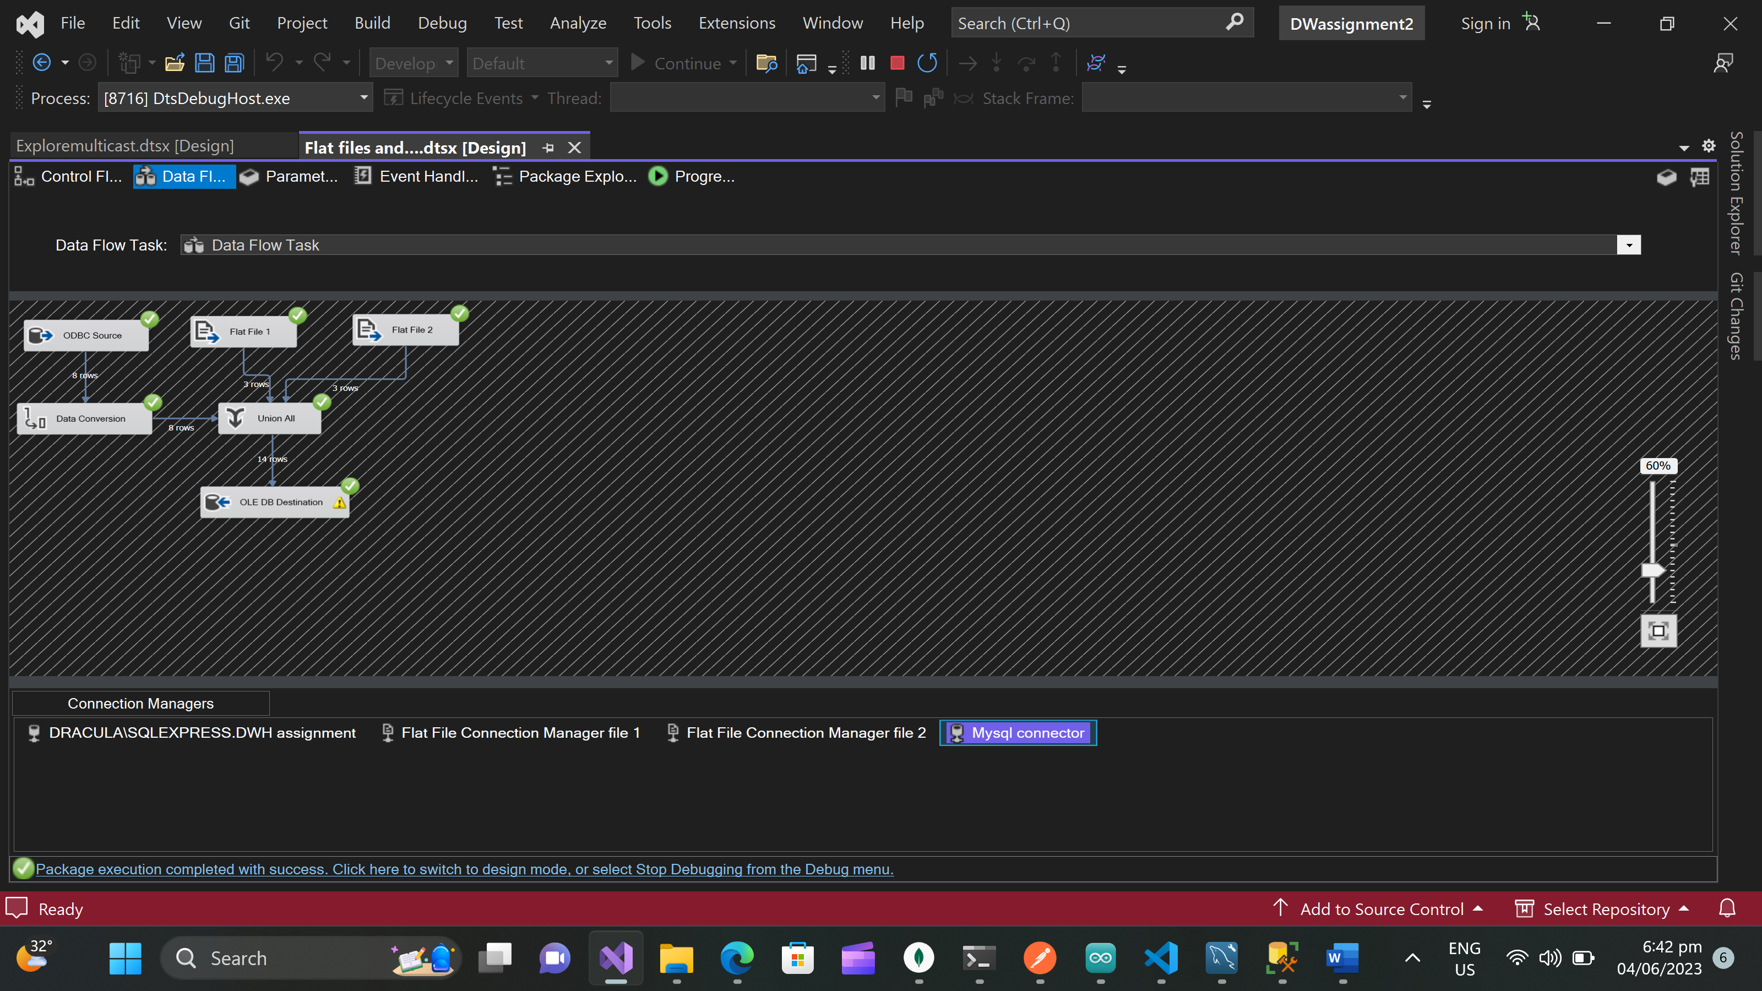 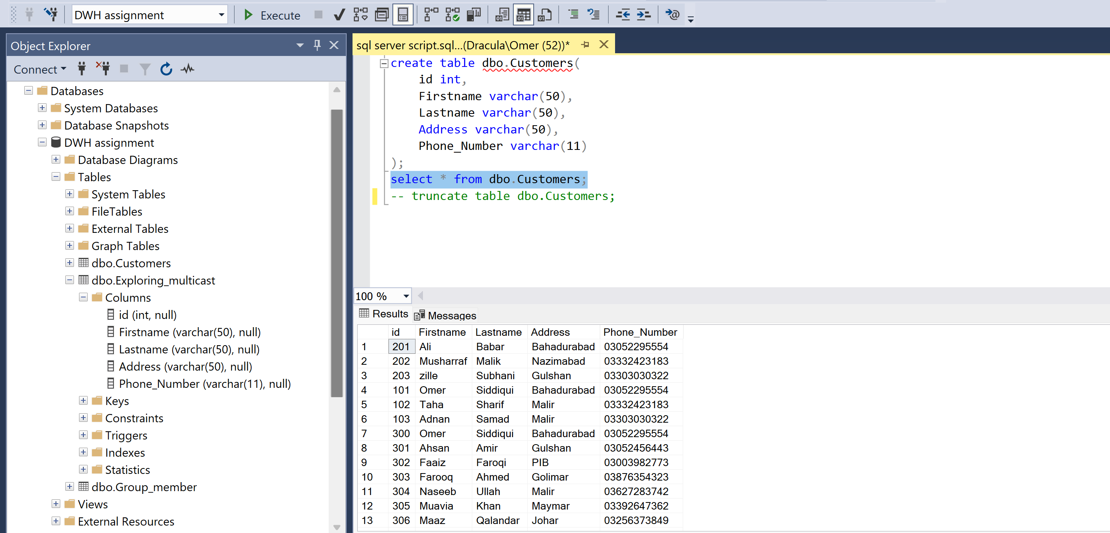

## Question 2:

What is the purpose of Multicast. Explain with example

Multicast helps you to put same data in multiple stores. For example you have your data in my sql and you want to push the same data into excel file and smss then multicast is really helpful in this case.

### Sql script for Explaining multicast(MY SQL)

create database DWass2;

use DWass2;

create table Exploring_multicast(

id int,

Firstname varchar(50),

Lastname varchar(50),

Address varchar(50),

Phone_Number varchar(11)

);

select * from Exploring_multicast;

--truncate table Exploring_multicast;

insert into Exploring_multicast(id,Firstname,Lastname,Address,Phone_Number) values(1,'Omer','Siddiqui','Bahadurabad','03052295554');

insert into Exploring_multicast(id,Firstname,Lastname,Address,Phone_Number) values(2,'Ahsan','Amir','Gulshan','03052456443');

insert into Exploring_multicast(id,Firstname,Lastname,Address,Phone_Number) values(3,'Faaiz','Faroqi','PIB','03003982773');

insert into Exploring_multicast(id,Firstname,Lastname,Address,Phone_Number) values(4,'Farooq','Ahmed','Golimar','03876354323');

insert into Exploring_multicast(id,Firstname,Lastname,Address,Phone_Number) values(5,'Naseeb','Ullah','Malir','03627283742');

insert into Exploring_multicast(id,Firstname,Lastname,Address,Phone_Number) values(6,'Muavia','Khan','Maymar','033926473629');

insert into Exploring_multicast(id,Firstname,Lastname,Address,Phone_Number) values(7,'Maaz','Qalandar','Johar','03256373849');

insert into Exploring_multicast(id,Firstname,Lastname,Address,Phone_Number) values(8,'Saim','Mehmood','Cantt','03006473838');

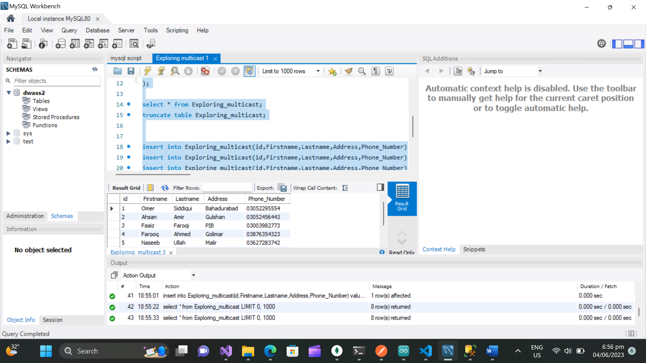

### Sql script for Explaining multicast(SSMS)

create database [DWH assignment ];

use [DWH assignment ];

create table dbo.Exploring_multicast(

id int,

Firstname varchar(50),

Lastname varchar(50),

Address varchar(50),

Phone_Number varchar(11)

);

select * from Exploring_multicast;

truncate table Exploring_multicast;

